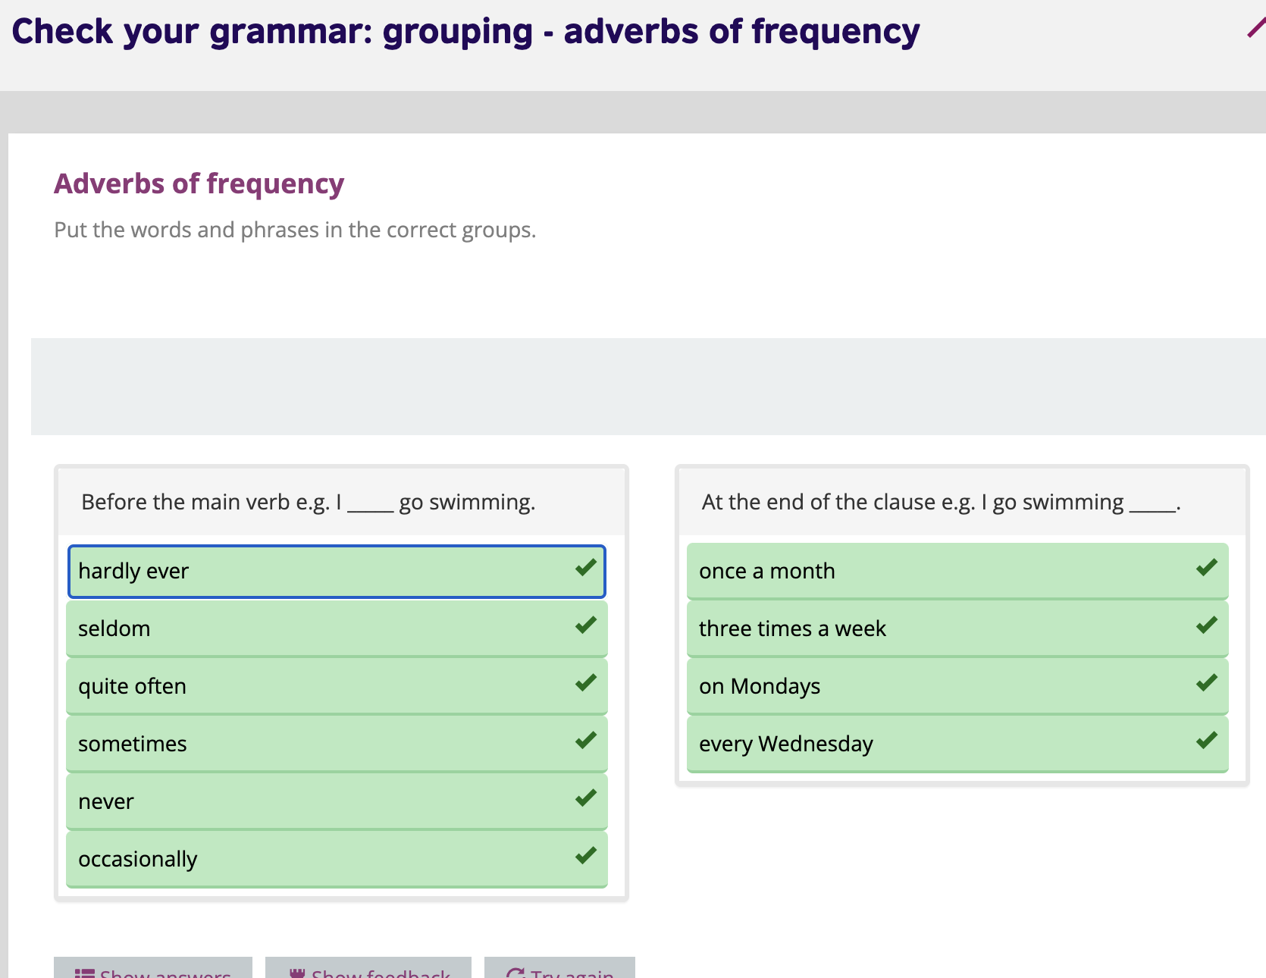

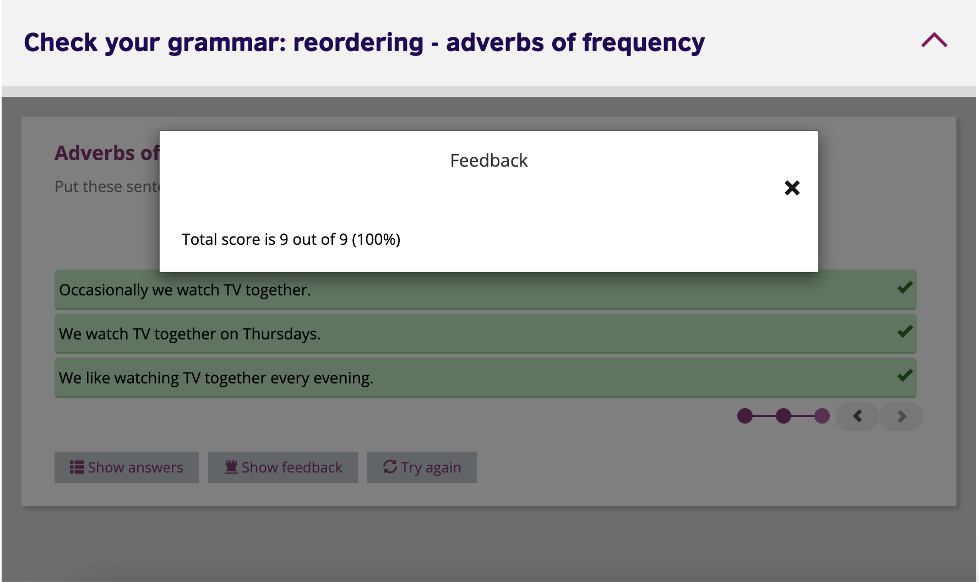

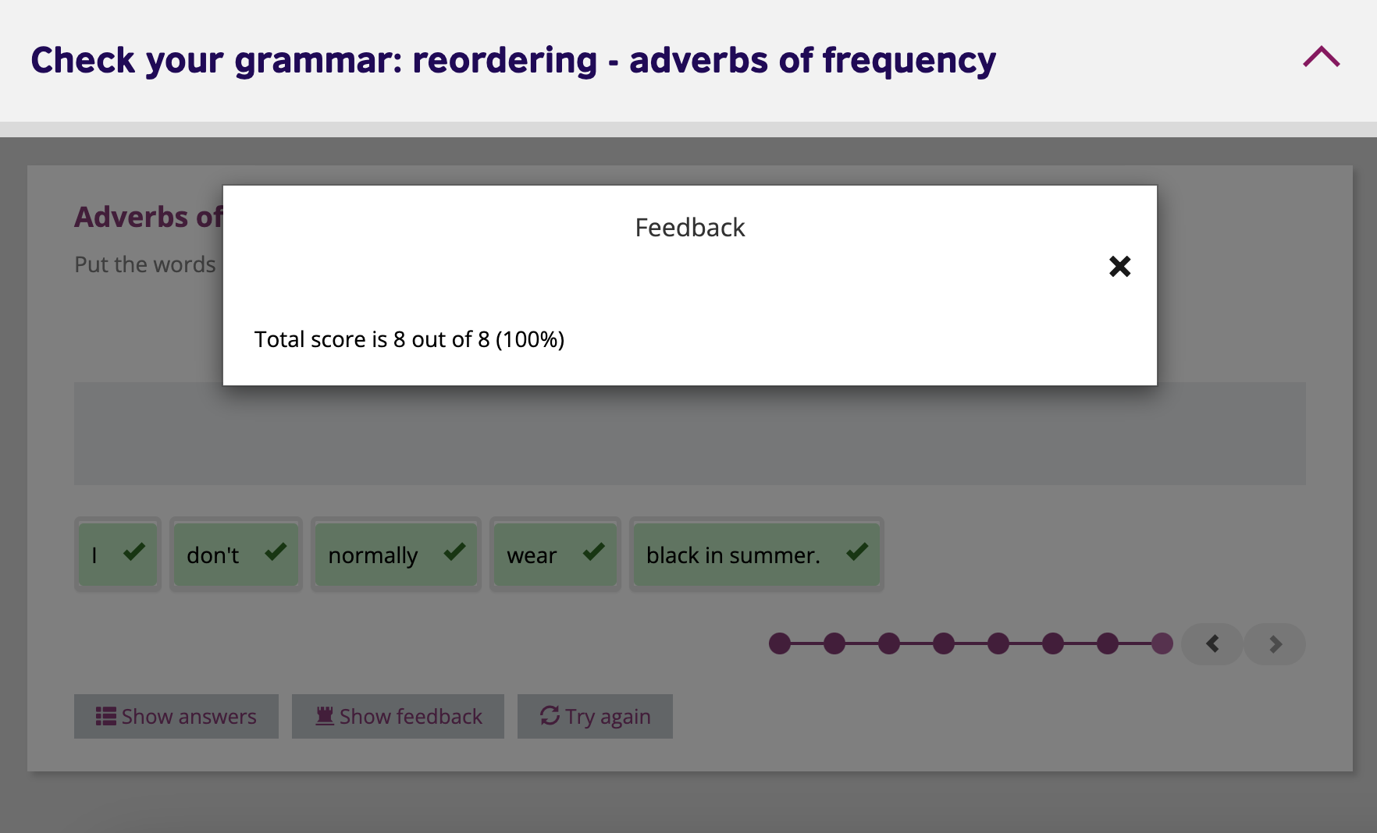

**IS THIS A REAL JOB? MEET ROY, THE HOLIDAY VOLUNTEER**

Roy **is** Canadian and **works** in a youth hostel in Corfu, Greece. He and the other hostel workers **are** volunteers - they **do not gets** money for their work. Every day Roy **gets up** at six and **has** breakfast in the hostel. He **does not cook** the meals. Cynthia **is** the chef and she **does** all the shopping and cooking. Every morning, Roy **cleans** the rooms and **helps** on the organic farm at the hostel, growing food for the guests. In  the afternoons, he  **does not work** and he usually **goes** to the beach. After dinner, he and the hostel guests often **chat** together. ‘It **is** a great job,’ Roy says. ‘Everyone’s very friendly. I **do not want** the summer to end.’